6 DEMONSTRATE LINUX PRIVILEGE ESCALATION

AIM

To understand Linux privilege escalation techniques and learn how to identify and exploit common misconfigurations to gain higher privileges in the TryHackMe room “Linux PrivEsc.”

PROCEDURE

- Open the TryHackMe room “Linux PrivEsc” and study the basics of Linux privilege escalation.
- Learn different techniques such as exploiting sudo permissions, SUID binaries, cron jobs, and weak file permissions.
- Analyze system configurations and identify possible privilege escalation paths.
- Complete the tasks and gain root access using the given methods.

QUESTIONS

TASK 3 – Enumeration

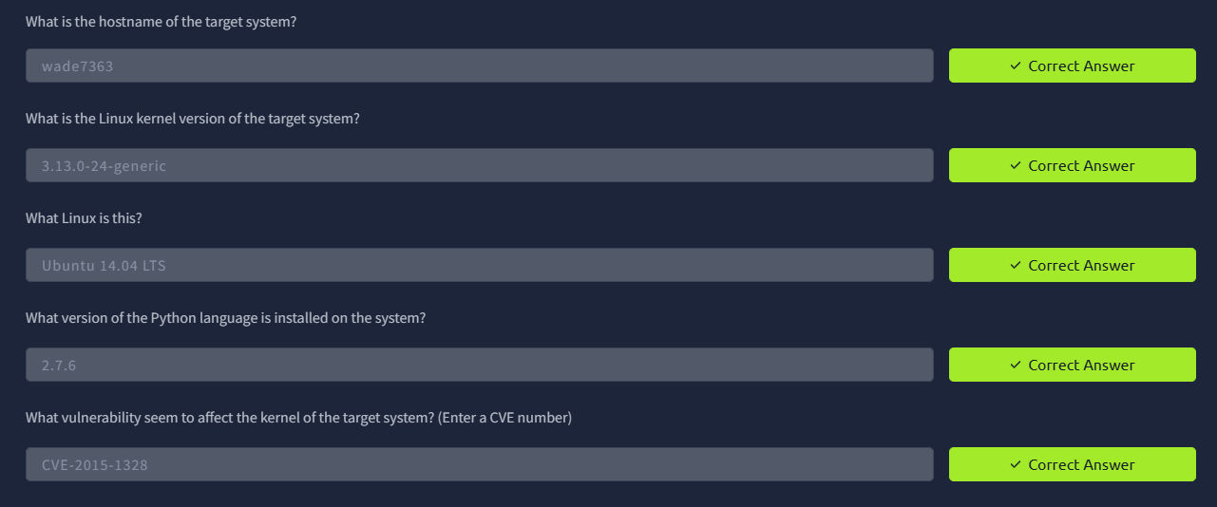

TASK 5 – Privilege Escalation: Kernel exploits

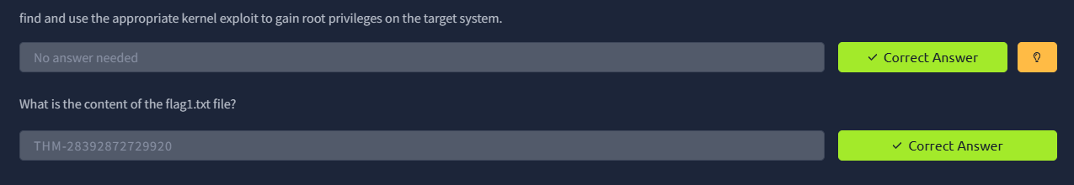

TASK 6 – Privilege Escalation: Sudo

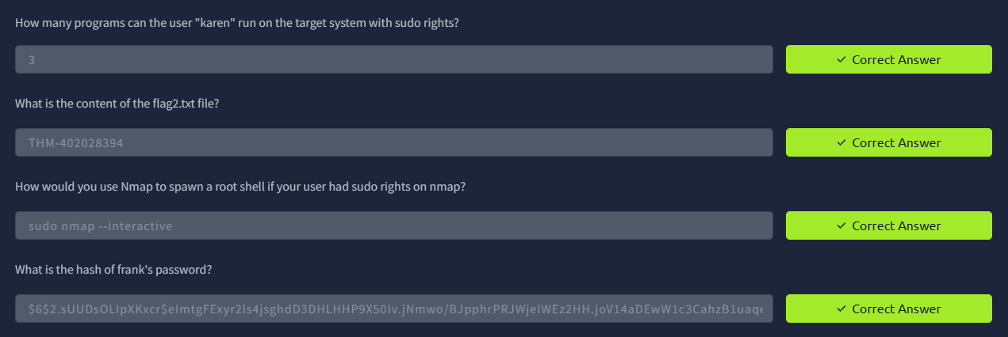

TASK 7 – Privilege Escalation: SUID



TASK 8 – Privilege Escalation: Capabilities



TASK 9 – Privilege Escalation: Cron Jobs

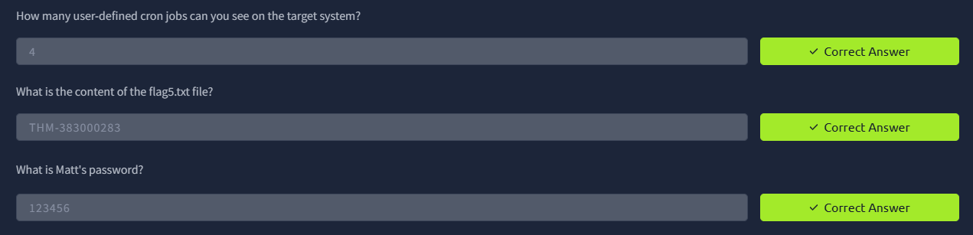

TASK 10 – Privilege Escalation: PATH

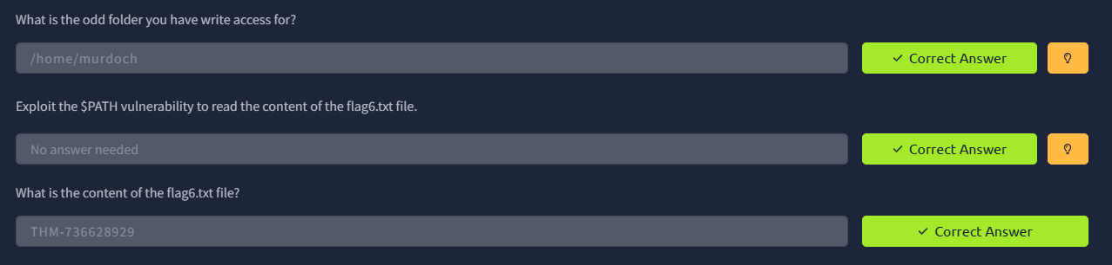

TASK 11 – Privilege Escalation: NFS

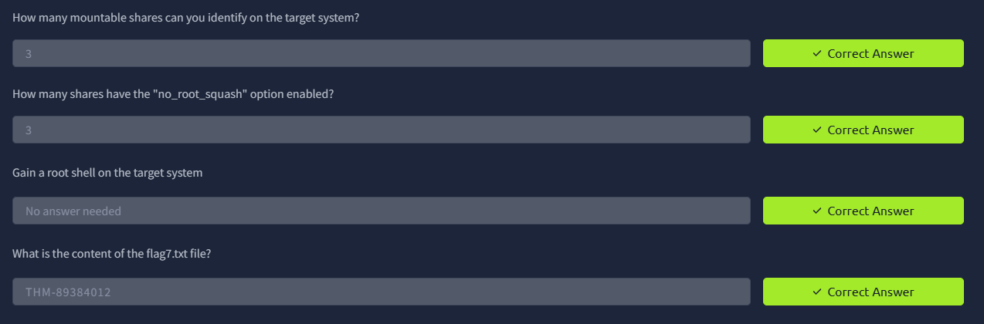

TASK 12 – Capstone Challenge



RESULT

Successfully learned various Linux privilege escalation techniques and understood how misconfigurations in Linux systems can be used to gain root privileges.

